

Projektmanagement und Teamorientiertes Projekt

Team 4: HACKLAB

Summarise of some of the hacking app that already exists on the market.

1. HACKER X

A mobile app where you can learn all the top Ethical Hacking skills through bite-sized courses created by professional Cyber Security experts. On this Ethical Hacking Learning app, you will be able to start with the basics of cybersecurity and hacking so that you can build your skills around it. You can build your hacking skills on the go from Hacking Tutorials on this app.

* 1. Android Version:

<https://play.google.com/store/apps/details?id=hacking.learnhacking.learn.hack.ethicalhacking.programming.coding.hackerx.cybersecurity>

1. Apple Version:

<https://apps.apple.com/de/app/hacker-x/id1542444199>

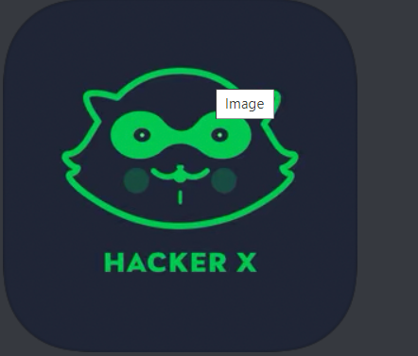

1. Hack RUN

Hack RUN is based on languages such as DOS and UNIX that simulate a real operating system so you may learn a little programming along the way although it should be stressed that Hack RUN is accessible enough for anyone to play. Your main task is to snoop on employees in a mysterious company to find out exactly what the company is doing. Read files and emails to find clues and riddles which will give you access to more accounts.

1. Android Version

<https://hack-run.en.softonic.com/android>

1. Apple Version

<https://apps.apple.com/de/app/hack-run/id407678003>

